Task No. #09
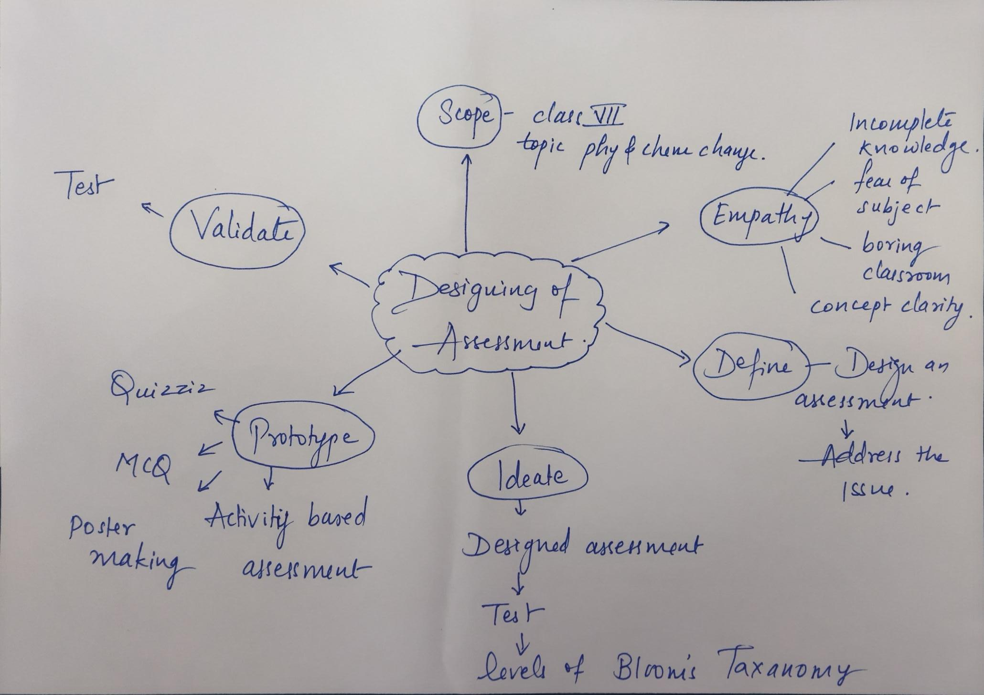
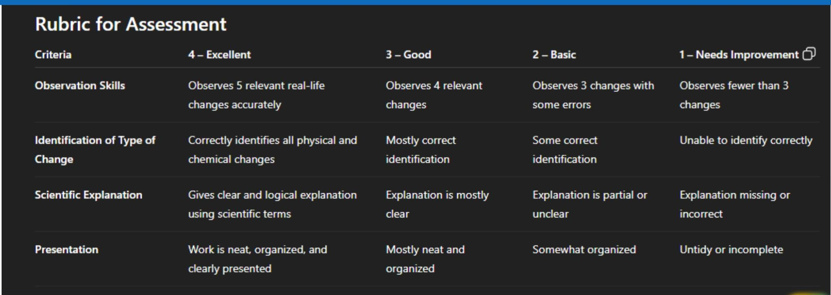
Name :Mrs Shital Talokar
Group activity ( Team 2 Idea bots )

